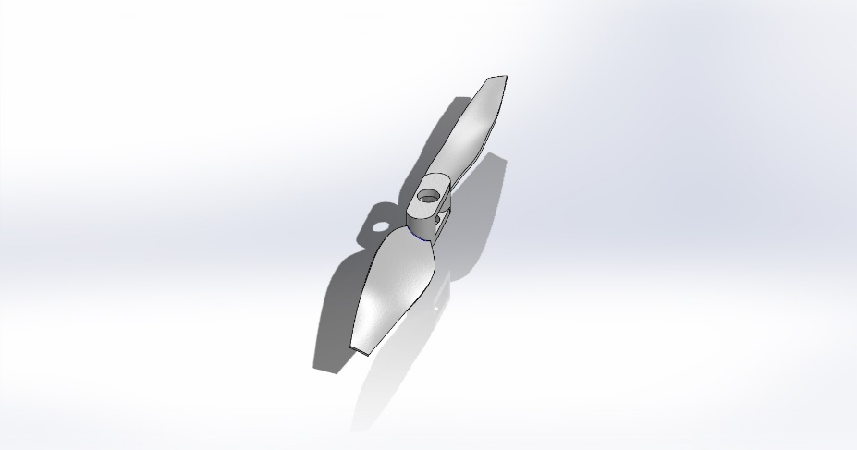
  Simulation of Propeller^Drone Project
  Date: Wednesday, May 3, 2023
  Designer: AZHA
  Study name: SimulationXpress Study
  Analysis type: Static
  Table of Contents
  Description 1
  Assumptions 2
  Model Information 2
  Material Properties 3
  Loads and Fixtures 3
  Mesh information 4
  Study Results 6
  Conclusion 8

Description
No Data

Assumptions

Model Information

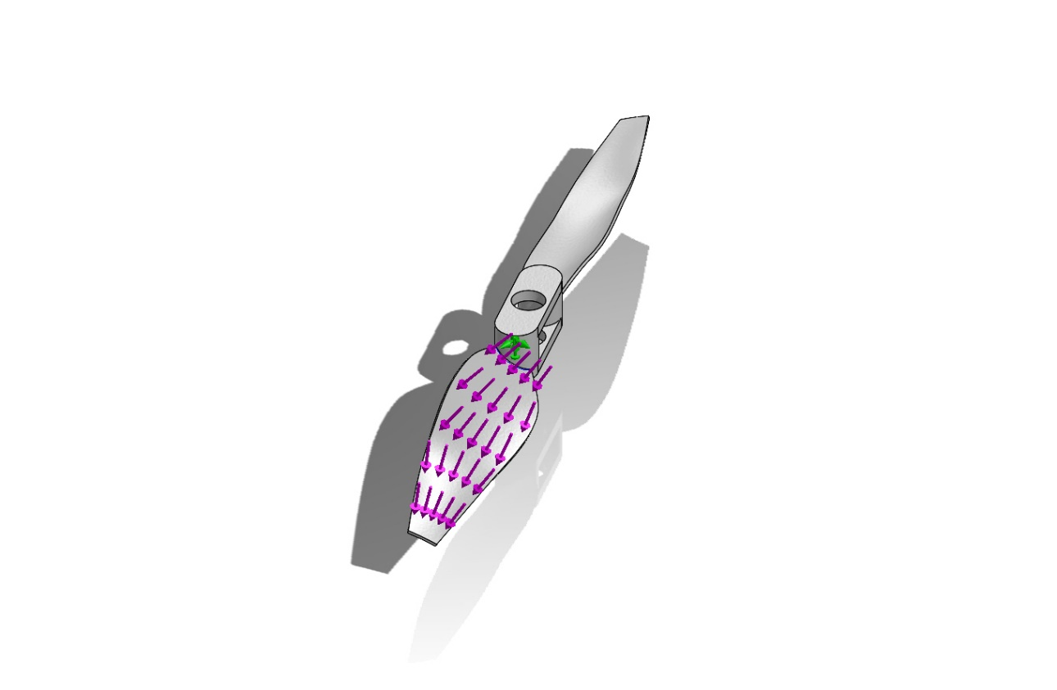
Model name: Propeller^Drone Project
Current Configuration: Default
Solid Bodies
Document Name and Reference | Treated As | Volumetric Properties | Document Path/Date Modified
DeleteFace3  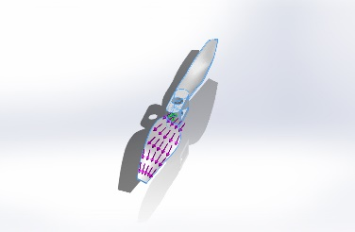 | Solid Body | Mass:0.00310738 lb  Volume:0.0843253 in^3  Density:0.0368499 lb/in^3  Weight:0.00310527 lbf | C:\Users\frcc\AppData\Local\Temp\swx9792\VC~~\Drone Project\Propeller^Drone Project.SLDPRT  May 3 18:09:18 2023

Material Properties
Model Reference | Properties | Components
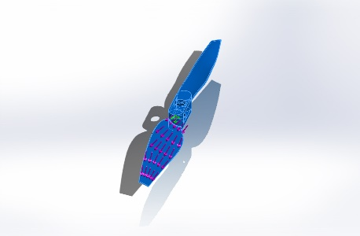 |  | SolidBody 2(DeleteFace3)(Propeller^Drone Project)
  Name: | ABS
  Model type: | Linear Elastic Isotropic
  Default failure criterion: | Unknown
  Tensile strength: | 4,351.13 psi

Loads and Fixtures
Fixture name | Fixture Image | Fixture Details
Fixed-1 | 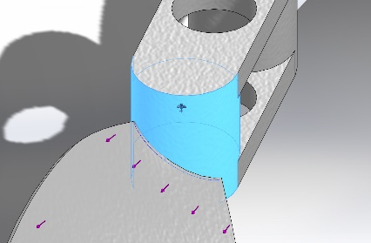
  Entities: | 1 face(s)
  Type: | Fixed Geometry

Load name | Load Image | Load Details
Force-1 | 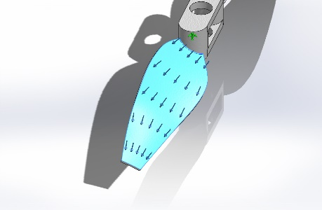
  Entities: | 1 face(s)
  Type: | Apply normal force
  Value: | 100 lbf

Mesh information
Mesh type | Solid Mesh
Mesher Used: | Standard mesh
Automatic Transition: | Off
Include Mesh Auto Loops: | Off
Jacobian points for High quality mesh | 16 Points
Element Size | 1.2555 mm
Tolerance | 0.0627748 mm
Mesh Quality | High

Mesh information - Details
Total Nodes | 15868
Total Elements | 8310
Maximum Aspect Ratio | 15.698
% of elements with Aspect Ratio < 3 | 68.7
Percentage of elements with Aspect Ratio > 10 | 0.156
Percentage of distorted elements | 0
Time to complete mesh(hh;mm;ss): | 00:00:01
Computer name:
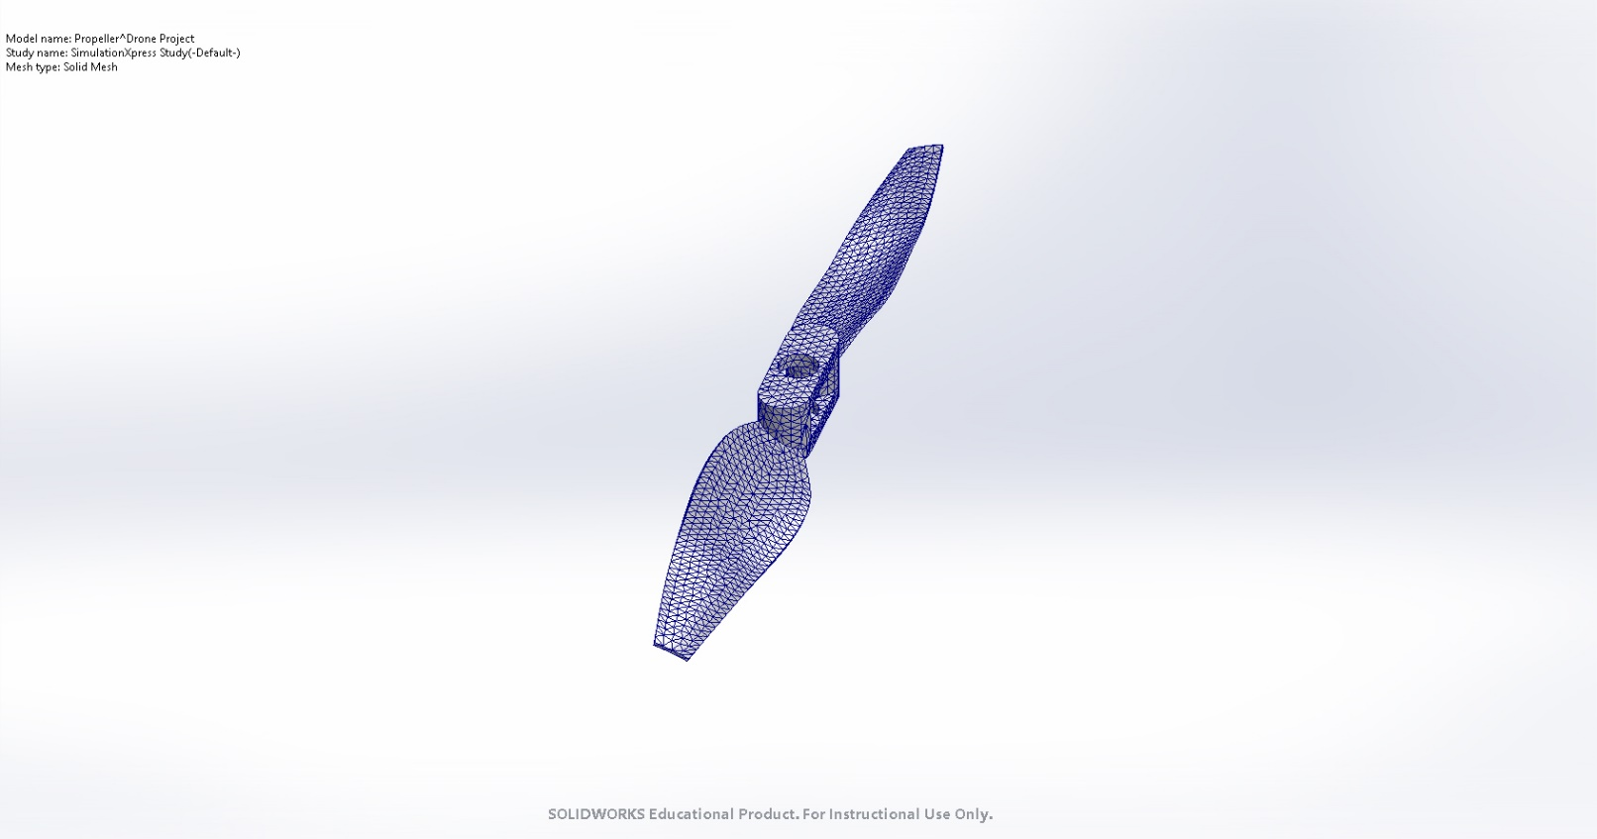

Study Results

Name | Type | Min | Max
Stress | VON: von Mises Stress | 3.406e-06psi  Node: 12598 | 4.522e+06psi  Node: 14137
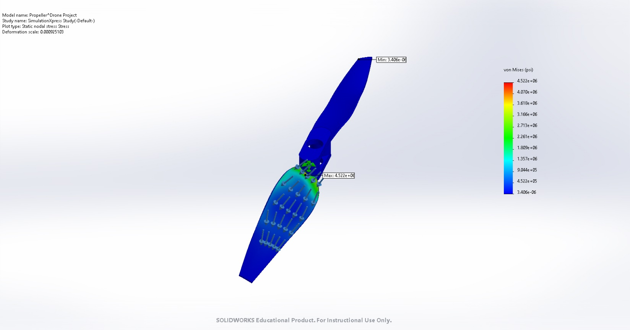
Propeller^Drone Project-SimulationXpress Study-Stress-Stress

Name | Type | Min | Max
Displacement | URES: Resultant Displacement | 0.000e+00in  Node: 63 | 5.396e+02in  Node: 1356
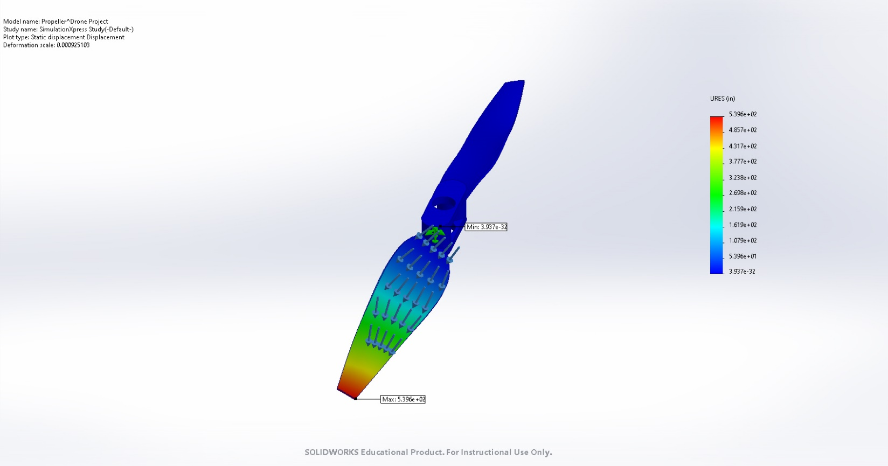
Propeller^Drone Project-SimulationXpress Study-Displacement-Displacement

Name | Type
Deformation | Deformed shape
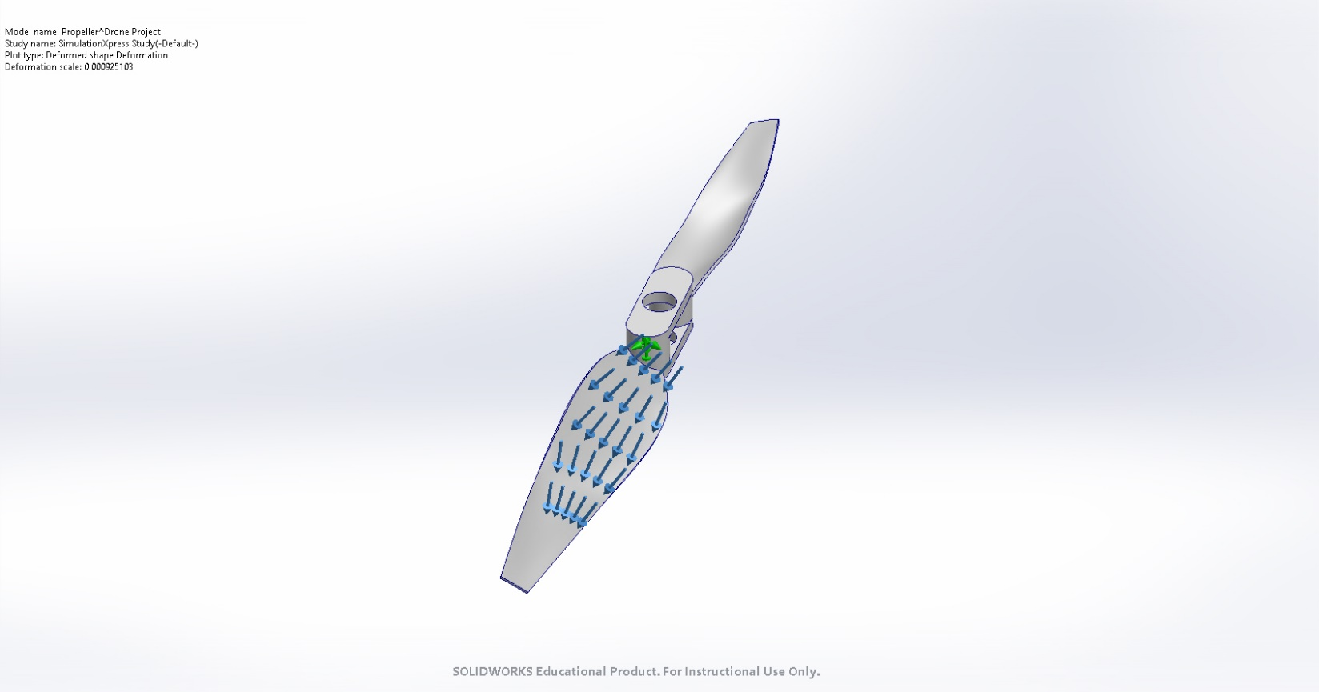
Propeller^Drone Project-SimulationXpress Study-Displacement-Deformation

Conclusion

